Our Ref: PAS/JHA

July 2020

Dear Student

We hope that you and your families are safe and well.
A Level Results Day – 13th August 2020
The 2020 A Level Results Day will be held on the original date as planned. Calculated grades for all A Level, AS and Level 3 Vocational qualifications will be provided by the exam boards and distributed by the school on Thursday 13th August at 8am. At this point students will be able to begin the process of confirming through UCAS Track whether their applications for university have been successful. We have provided a preparation guide that will be made available on Frog, to ensure that students are clear on the necessary preparation for this process.
Due to the Results embargo set by the exam board regulator, results will not be available before this time. We will be distributing the results through five stations around the school, minimising the time that students are in the school and the subsequent risk of transmission. Although we understand that parents may wish to accompany students, access to the building for the collection of results will be restricted to those collecting the results only. In the vast majority of cases, this will be the students themselves.
Students should collect their results in person wherever possible. If they are unable to attend, they can give authorisation to someone else to collect results on their behalf.

- They must give their nominated person a signed letter of authority to collect their results. Photographs of letters are not acceptable.
- The nominated person must be named in the letter and bring photographic ID. This includes parents.
- The nominated person must bring the letter of authority and ID with them on results day.

We hope and expect universities to be flexible with students with regards their progression to the next stage of their education. Sixth Form pastoral staff will be available to support students with Clearing, Adjustment and where it is necessary to discuss their progression options. This will be held in the English block with access via the side entrance and be on a drop in basis. Further information on the Results Day process can be found at the following website.
https://www.ucas.com/undergraduate/results-clearing

For all students accessing the school site, the key things to remember are as follows:
- Under no circumstances should you attend the appointment if you have a high temperature, new continuous cough or loss or change to your sense of smell or taste. In these circumstances you should contact the exams office to discuss alternative ways of collecting results.

- Current Public Health England advice is that everyone must wear face masks on public transport. Wearing a face covering or face mask in schools or other education settings is not recommended.
- Public Health England recommends that the best way to reduce any risk of infection is through good hygiene and avoiding direct or close contact with any potentially infected person.
- Wherever possible you should walk or cycle to school. Bikes should be locked up 2m apart.
- Entrance to the building for all those collecting results will be via the designated distribution stations only. Signs and members of staff will guide you on where to go and what to do whilst on site.
- After you have collected your results you should follow signage and staff instructions to leave site, unless you need further support from the Sixth Form team. Please do not loiter or agree to meet friends on site.
Year 13 Clearance Procedure
It is essential that you come into school to return resources to the school to allow them to be provided for future students in a safe way for September. We will also be able to distribute all copies of the yearbook to those who bought one. Therefore we would ask that you return the following items to school (Main Reception) by Friday 4th September 2020:
- All subject specific textbooks provided by departments. If you have bought copies and no longer need them, these may also be used by departments in the future, although this is up to you.
- All books or other resources borrowed from the library.
- Please remember to return your locker key. If you have lost this, please arrange with your locker buddy to have another one cut.
- You will need to return your ID badge.
- Finally, there is of course an amnesty on any other school books from any year that you might discover at home – please bring them in too.
We will provide full details of this process on Results Day.
We look forward to seeing you then.
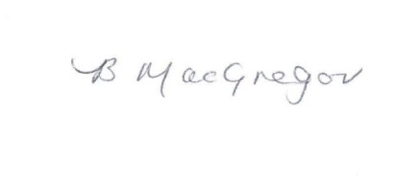
Yours sincerely
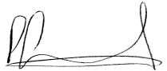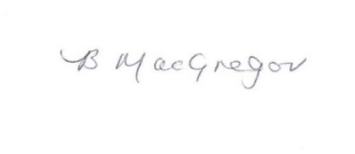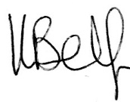
Peter Snowdon Beth MacGregor Katie Belfield
Director of Post 16 Head of Year 13 Head of specialist Support

